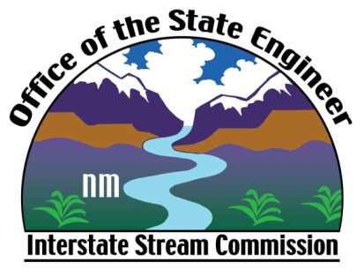

Office of the State Engineer/

Interstate Stream Commission

Speakers Bureau Request Form

The Office of the State Engineer/Interstate Stream Commission would welcome the opportunity to speak with local groups and organizations. If your group is interested, please provide us with the following information.

Print this form and mail or e-mail to:

Office of the State Engineer
Public Information Officer Lela Hunt
5550 San Antonio Dr NE
Albuquerque, NM 87109
(505) 383-4092

Or include all of the following information in e-mail, with “Speakers Bureau” as the subject line, to: lela.hunt@state.nm.us

Name of Group or Organization:

Contact Person:

Contact Phone Number and E-mail address:

Preferred Date(s) Requested:

Please list any particular issues you would like the speaker to address:

Other Comments:

